**Government of Serbia**

**Call for Action**

**Early Childhood Development**

Development for Each Child and the Society

**Joint Message from three ministers of the Government of the Republic of Serbia: Support to Early Childhood Development**

Policymakers and researchers at the global level agree that Early Childhood Development is one of the most effective and efficient public policy for overall development of the society. The success of the Early Childhood Development programs make influence in the right timing: they support children in their early years, period when human brain develops faster than at any other time in life, and responds most readily to interventions.

With this Call for Action we accelerate the right of every child in the Republic of Serbia to develop to the maximum extent possible, through providing tailored made Early Childhood Development programs.

This Call for Action is based on the Convention on the Rights of the Child, which Serbia has signed, and Sustainable Development Goals, whose development and implementation Serbia has been supporting, but before that, it is based on the best interest of every child in the Republic of Serbia. With this Call for Action we put the Early Childhood Development high on the national agenda.

This Call for Action aims to initiate comprehensive early childhood response from the society for children and their parents and caregivers – from the prenatal period through children’s entry into school. In order to be effective, early childhood development actions need to be implemented from various sectors, institutions and organizations.

To ensure good quality of interventions, but also their effectiveness, the response needs to be well coordinated and function as one program and not series of fragmented activities. Partnership between family, institutions, development partners and civil society organizations need to be better linked to serve the need of a child.

The Early Childhood Development programs represents the window of opportunity for the society to improve outcomes for children, especially children living in underprivileged circumstances or in disadvantaged communities.

Investing in social support for children at an early age has multiple advantages. By investing in children now, we will realize multiple benefits for today’s children and for society in general in the future. That's why we begin to work without delay.

**Call for Action: 6 goals for improving ECD in Serbia**

In order to strengthen ECD system in Serbia the Government of Serbia with the support from UNICEF initiates Call for Action for the entire society. The goal of the Call for Action is that all young children reach their full developmental potential in supportive families and communities, with the special focus on the most vulnerable.

For ECD system in Serbia to be effective and efficient it needs to reach work toward the following goals:

**1. Support to Parenting.** The family has the unique role in providing support in health and development of a child. Dealing with parental knowledge, practice and skills to stimulate early learning, responsive and positive parenting is fundamental strategy to improve the chances of children to develop optimally. Three family strengthening elements increase the likelihood that families will be able to provide adequate care for their children: access to quality services (e.g. prenatal care, immunization, nutrition counseling); building skills (e.g. care and non-violent childcare techniques); and support for the whole family (e.g. cash benefits and social security services). This goal may include the promotion of home visits programs, the introduction of an advisory and educational activity programs, information campaigns to ensure that parents have sufficient information about the importance of early childhood, but also to improve the quality of life for parents.

Parental support programs should be reinforced particularly for at risk families so to prevent early negative experiences including institutionalization and their negative effects on children.

**2. Early Childhood Education and Care is available to every child.** In order to ensure the well-being of each child and equal access to high-quality learning opportunities in early childhood, it is necessary to improve the fairness and accessibility of pre-school programs that respond to the needs of children and parents in local communities, and to work on increasing spatial capacities for preschool education. Children from vulnerable groups have special benefits from pre-school education and should have a priority on enrollment. Bearing in mind that only quality preschool programs provide support for the well-being and overall development of the child, it is necessary to develop new Fundamentals of the program of preschool education and provide support to the professionals in the system in order to understand and apply the conceptual starting points in the activity, modernize the initial education of educators and improve the monitoring and evaluation.

**3. Safe Childhood.** Children should grow up in safe, peaceful, multicultural communities and society, protected from neglect, violence and poverty. It's necessary to strengthen systems for prevention and recognition of abuse in the early years as well as strengthening systems for responding to abuse and violence, we need to improve poverty reduction programs through adequate cash benefits and services. To ensure the right of every child to play and safety, the environments in which children grow should be improved. Serbia will continue to build safe and incentive outdoor places for the play of children in all communities.

**4. Strengthening Health Care.** To ensure a healthy start to life for every child, we need to take care of their mothers that they have adequate nutrition, accessible and quality prenatal care and safe delivery in an environment that encourages breastfeeding and emotional closeness between mother and child from the first day. Health care system should ensure timely immunization, provision of counseling activities to parents for optimally child stimulation, child development, nutrition and health of children in general, but also to preserve the mental health of mothers and fathers. Support should be given to developing a system for monitoring and supporting the development of the child and providing early intervention for children who need them at the level of primary health care. An additional capacity building for service providers and health care institutions working with young children and their parents is necessary. Existing mechanisms such as patronage service, pediatricians, development counseling units, health mediators will be further scaled up and strengthened.

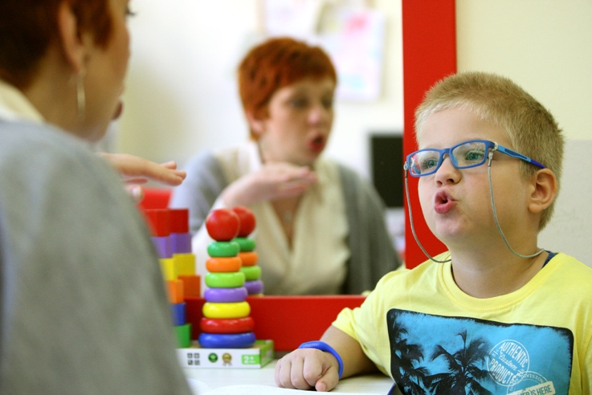

**5. Early Childhood Interventions.** To detect and mitigate developmental difficulties and disruptions, early identification of children in need is necessary. The way and plan of work with each child should be based on an assessment of its functionality, including the definition of short-term and long-term goals. Support should be given to creating a unique individual support plan for a child and family involving all institutions/sectors and comprehensive services. These services are provided using family focused approach and they are adjusted to different needs of children and in the context, they live in. Parents and families living with children difficulties need support to overcome multiple problems they are facing.

**6.Policy and Institutional Consolidation.** Effective child support programs in early childhood require cross-sectoral interventions, both at the policy level and in the implementation stage. It is therefore necessary to ensure the prioritization and coordination of policies and mechanisms for improving social support for children at an early age and their families in the framework of the integrated agenda of Serbia. There should be mechanisms at the national and local level that will allow the coordination of programs and services that every child and family will receive holistic support for well-being and comprehensive development that is necessary to them. The existing strategic and legislative framework for social support for children in different sectors (health, education, social protection) needs to be consolidated, supplemented and ensured its implementation through adequate funding. The National Council, within which there will be a separate body with a mandate for early childhood support, should define medium-term priorities, ensure the coordinated implementation and follow-up of child support policies for early childhood.

**–––––––––––––––––––––––––––––––**

**Zlatibor Lončar**

*Minister of Health of Serbia, Government of Serbia*

**–––––––––––––––––––––––––––––––**

**Zoran Đorđević**

*Minister of Employment, Labor, Veteran and Social Affairs Government of Serbia*

**–––––––––––––––––––––––––––––––**

**Mladen Šarčević**

*Minister of Education, Science and Technological Development, Government of Serbia*

**–––––––––––––––––––––––––––––––**

**Slavica Djukić Dejanović**

*Minister without portfolio responsible for demography and population policy in the Government of Serbia*

*President of the Council for Child Rights*

**Why Early Childhood Development is the right decision?**

**The best support child’s brain development.** Human brain develops faster after conception and through the ages of 2-3 than at any other time in life. Approximately 90% of the brain’s weight develops by age 3. In the first years of life, neurons in human brains form new connections at the astounding rate of 700-1000 per second, a pace that is not repeated again. At 3 years of age, a child’s brain is twice as active as an adult brain and 50–75% of energy consumption in the first few years of life is allocated to brain development. Everything that child sees, touches, tastes, smells or hears in early years helps to shape the brain for thinking, feeling and learning.

**Successfully decreases toxic stress.** When the child is raised in extreme poverty, does not have a stable caregiver or the caregiver is not able to respond with affection or nurturing, the child is experiencing unbearable stress often called “toxic stress”. Examples include conditions related to poverty, maternal depression, child abuse and neglect or institutional living. This early negative events have been proven to have extensive effects on the child development, with negative outcomes observed into adulthood.

**The most vulnerable benefit the most.** Research shows that the children who are at greatest disadvantage stand to benefit the most from early childhood programs. Also, various studies prove that ECD investment can decrease large cognitive differences which exist between children in the poorest and richest segments of society. The strategy for improving the development of children in the earliest childhood and their families is one of the few public policies that promote justice and social cohesion in society, and at the same time the productivity of the economy and society in general.

ECD programs for disadvantaged children promote schooling, raise the quality of the workforce, enhance the productivity of schools and reduce crime, teenage pregnancy and welfare dependency.

**Create high investment return.** Economists agrees that investing in early childhood development programs is one of the most cost-effective ways to achieve more sustainable growth. Analysis show that investment spent on improving early child development can create returns which are on average 4 to 5 times the amount invested, and in some cases, much higher. Remedial programs in the adolescent and young adult years are much costlier in producing the same level of skill attainment in adulthood.

**The cost of inaction is high for entire society.** Consequences of inaction impact not only present, but also future generations, and the future costs of suboptimal development can be double that of current investments in the health and education sectors. Children who are not nurtured properly in the early years may forfeit a quarter of their earning capacity as adults. Although interest for ECD has grown globally, it remains a neglected issue, particularly in less developed countries where the need is even bigger.



*Source: European Expert Network on Economics of Education (2006)*

**Early Childhood Development is part of the relevant global, EU and national policy framework...**

Under the Convention on the Rights of the Child, the Convention on the Rights of Persons with Disabilities, governments around the world have taken upon themselves the responsibility of ensuring that all children, irrespective of ability or disability, enjoy their rights without discrimination of any kind. Serbia is one of the countries that has ratified both conventions.

Early Child Development has been recognized as one of the priorities in the following documents:

**The UN Convention on the Rights of the Child** highlights that a child has a right to develop to “the maximum extent possible” and that state parties should provide “appropriate assistance to parents and legal guardians in the performance of their child-rearing responsibilities and shall ensure the development of institutions, facilities and services for the care of children”.

**Convention on the Rights of Persons with Disabilities** reminds that “if young children with disabilities are identified and supported early, they are more likely to transition smoothly into pre-primary and primary inclusive education settings”. This Convention also underlines the role of the family for child’s development and the role of the State in supporting the family.

**Sustainable Development Goals** (SDG) emphasize that investing in early child development has become not only an end but also a condition for achieving many other Sustainable Development Goals: eradicate poverty and hunger and improve nutrition for children, provide a healthy life, provide lifelong learning, achieve gender equality and reduce inequalities. The goals of sustainable development include the following specific goal of early childhood development: "By 2030, ensure that all girls and boys have access to quality care, as well as pre-school education, to be ready for primary education." In this sense, the Sustainable Development Goals are a historic opportunity for prioritizing and investing in the early development of children.

**UN Guidelines for the Alternative Care of Children** stresses that “organizations and authorities should make every effort to prevent the separation of children from their parents or primary caregivers, unless the best interests of the child so require” (article 154).

**The Europe 2020 Strategy** has target that by 2020 at least 95% of pre-school children of 4 years or older should participate in early childhood education. Countries’ improvements in relation to the target are monitored on a yearly basis.

**The EU Common European Guidelines on the Transition from Institutional to Community-based Care** provide practical advice about how to make a sustained transition from institutional care to family-based and community-based alternatives for individuals currently living in institutions and those living in the community.

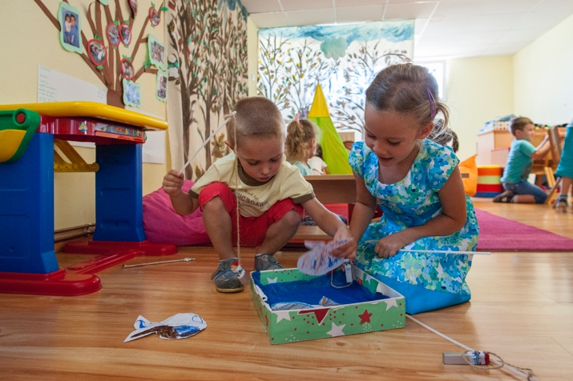

**The Employment and Social Reform Program** of the Government of Serbia defines the objective to “increase support to (biological) families at risk, continue the deinstitutionalization process and develop non-institutional community-based services”.

**The Action Plan for Negotiation Group for Chapter 23** supports these conclusions. Action Plan obliges Serbia to protect the interests of the child by strengthening its biological family through organizing support social services for children with intellectual disabilities and their families “to prevent institutionalization”. Action Plan also envisage establishing Centers for Family Support in 4 cities (by 2019), in the context of the transformation of the residential institutions for children and definition of standards for intensive family support services and setting up the system of financing the intensive family support service